SCENARIO

Uganda has the second youngest population in the world. More than three quarters (78 per cent) of its citizens are below the age of 35, and this youthful population is projected to double in the next 25 years. As a result, stresses on the education, health, and protection systems designed to support healthy children and youth will only grow.

SUPPORT MATERIAL

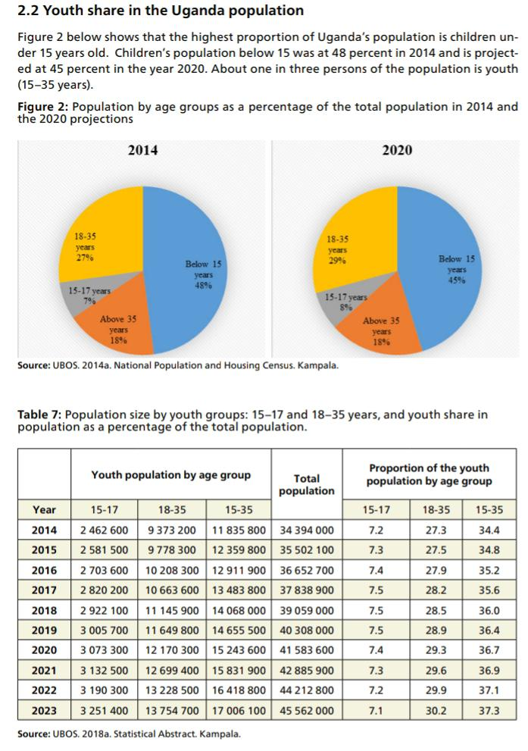TASK

Using traditional and Christian views, explain ways in which the scenario alerts young people together with their leaders to be productive to get relieved from the forthcoming chaos above.